Balqis, PSR success story.
On the release of PSR 2016 result, there is Balqis binti Hj Japar who was among the happy faces who managed to achieve flying colours in her PSR. She is one of the students under Riayah Wa Mahabbah programme where she stayed in Maktab Duli Pengiran Muda Al-Muhtadee Billah hostel during her Year 6 before sitting for PSR.
Before joining the programme, Balqis was initially a student at Sekolah Rendah Tumpuan Telisai in Tutong. “We saw her potential earlier on and her parents have been very supportive in her education,” Cikgu Ali Haji Nudin, Headmaster of Sekolah Rendah Tumpuan Telisai stated.

Balqis was selected for the programme which is a collaborative effort between Ministry of Education and BIBD. She was identified to potentially be developed further in her studies in line with one of the programme’s interest. Balqis admitted how she was at first apprehensive and sad at the thought that she will be away from her family for the first time. However, with the warm attention, care and guidance from the team of wardens at the hostel, she started to enjoy studying with her new friends and teachers who immediately become her family there.

Under the programme, students follow a well-rounded activity focused on academic, spiritual and physical development. The students there attended evening tuitions for Mathematics, English, Science and Bahasa Melayu and were given workshops and short courses to improve their achievements and self-confidence. Balqis and her friends also received religious guidance, performed daily prayers and attended scheduled religious lectures. In terms of keeping the body healthy as a necessity to help a healthy mind, the students also enjoyed health activities once a week.
From an average achievement, the previous school identified that Balqis had huge potential to achieve greater heights. Now with straight A results in her PSR, Balqis shared her key to success, “There is no secret but just effort; there are no short-cuts. Revision after school is necessary and always asks for explanations for subjects you do not understand. It is also important to listen and focus while the teacher is teaching in class. To get familiar with PSR format, I also practice past year paper.”
When asked about her time in Maktab Duli Pengiran Muda Al-Muhtadee Billah hostel, Balqis stated “I am very thankful to all the teachers and staff who help take care of me. I enjoyed studying together with my friends”.
Balqis’ father, Haji Japar, have also noted how the programme has positively impacted his daughter, “The most significant change is in terms of discipline. She has become more independent as an individual thanks to the well-organized activities catered for her”.

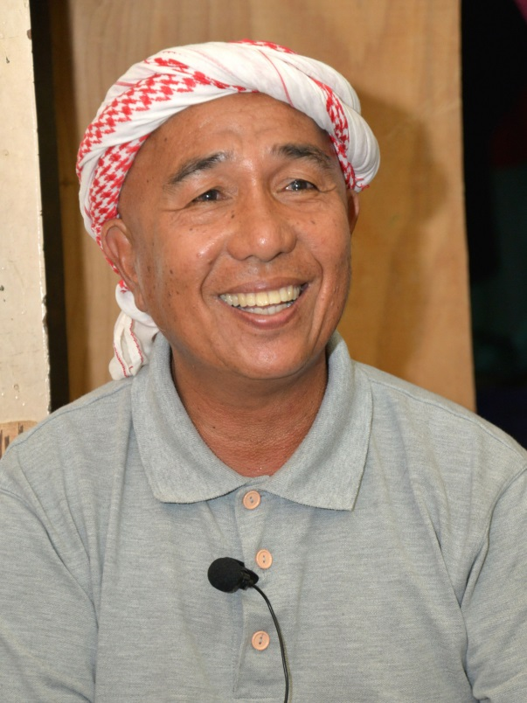
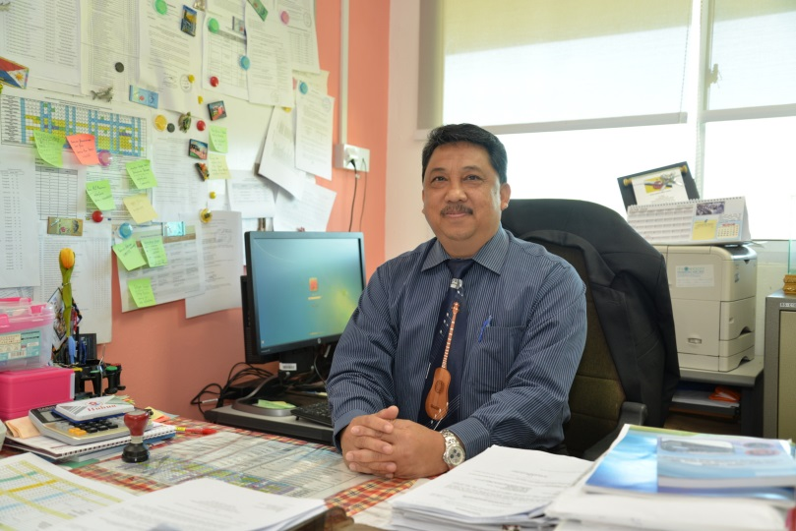
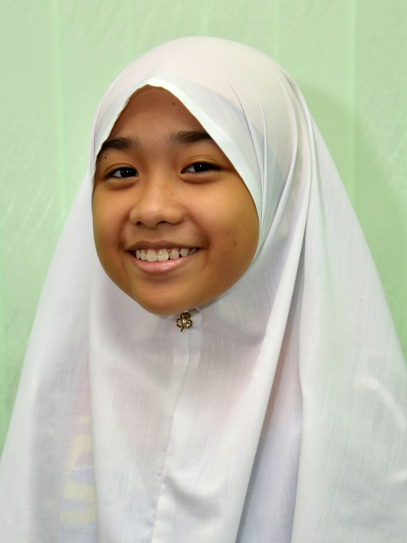
Cikgu Ali Haji Nudin
Headmaster Sekolah Rendah Tumpuan Telisai
Hj Japar
Balqis’s father
Balqis binti Hj Japar

